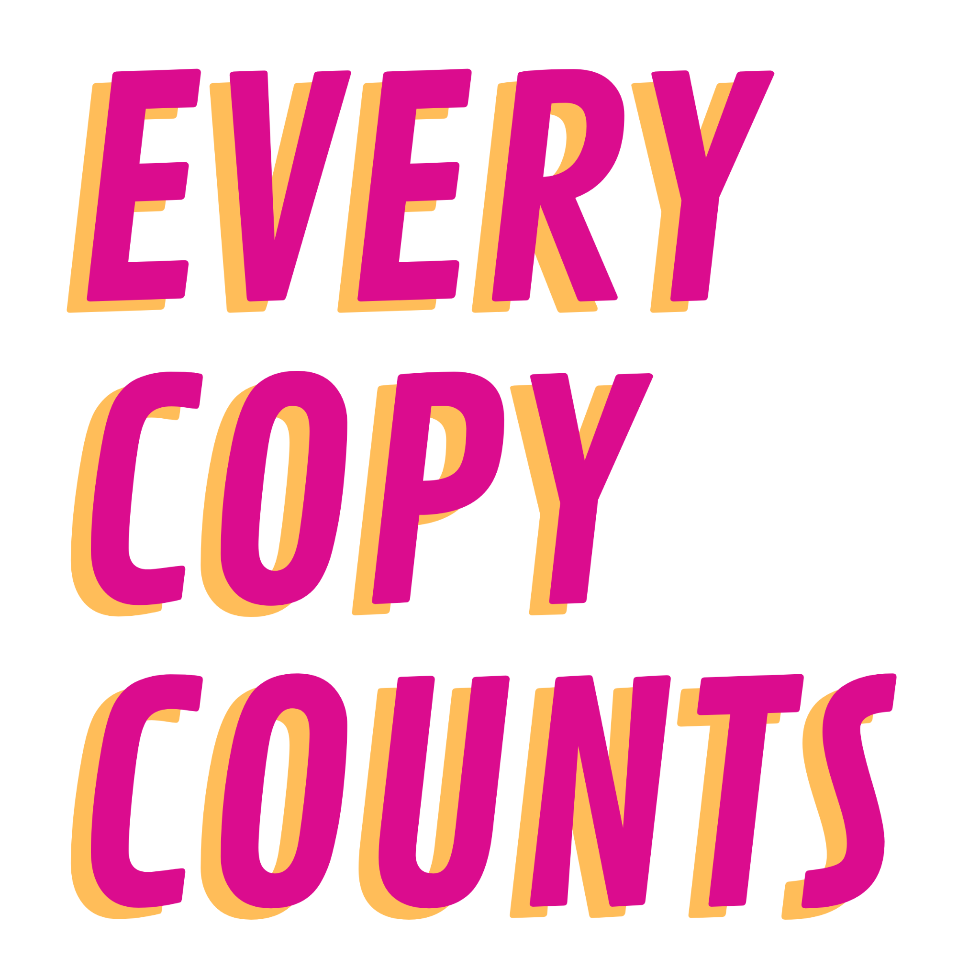

INFORMATION FOR SCHOOLS

Long Newsletter / website text to share with schools / staff

Great music teachers log their sheet music: make every copy count!

Every Copy Counts is a brand new campaign to help schools get the best out of the Schools Printed Music Licence. We are a team of music educators who are here to help and support you to understand and report on the printed music used in schools.

- Did you know that your school has a Schools Printed Music Licence, meaning that you can photocopy and arrange music for free?
- Did you know that your school is required to report data on any printed music you are copying and arranging?
- Did you know that by reporting your data, you help ensure that the right composers and songwriters get paid for their music?

The Schools Printed Music Licence enables teachers to copy and arrange music based on a set of straightforward terms and conditions, without any need for you to negotiate or fund the licence.

The licence is granted automatically to schools in England, Scotland and Northern Ireland by the Departments for Education, and fees paid by the Education Departments are distributed to music publishers, and then to creators.

However, to date less than 2% of schools have reported what music they are copying and arranging, meaning that the royalty distribution system is currently neither accurate nor fair.

If your school is photocopying / arranging music under the Schools Printed Music Licence, you are required to share information about this.

In return, teachers can access an exclusive set of resources created by teachers for teachers, exploring composing and songwriting in the classroom, guidance on licensing and the music publishing industry, and a digital pack containing a poster, certificate and logos for their school, so they can demonstrate their commitment to the campaign.

Next steps
1. Visit www.everycopycounts.co.uk
2. Register your school on the online portal
3. Upload information on what you are copying/arranging
4. Unlock free resources!

If you would like to find out more, please sign up to an Every Copy Counts drop in virtual sessions, for a short talk on the Schools Printed Music Licence, and to have your specific queries answered. Virtual drop in dates :
- Monday 29th November 2021 (4.30-5.15pm)
Wednesday 26th January 2022 (4.30-5.15pm)
Thursday 3rd March 2022 (4.30-5.15pm)
- Monday 4th April 2022 (4.30-5.15pm)
- Thursday 12th May 2022 (4.30-5.15pm)
- Tuesday 14th June 2022 (4.30-5.15pm)

Shorter Newsletter / website text to share with schools / staff

The Schools Printed Music Licence Explained

Every Copy Counts is a brand new campaign to help schools get the best out of the Schools Printed Music Licence. We are a team of music educators who are here to help and support you to understand and report on the printed music used in schools.

The Schools Printed Music Licence is a major advantage for schools. It enables teachers to copy and arrange music based on a set of straightforward terms and conditions, without any need for you to negotiate or fund the licence.

If your school is photocopying / arranging music under the Schools Printed Music Licence, you are required to share information about this.

In return you can unlock free resources created by teachers on composing and songwriting in the classroom, information on licensing and the music publishing industry, and a free digital pack of Every Copy Counts merchandise.

Visit Every Copy Counts now, start logging your sheet music data, access your free resources and make Every Copy Count!

Social media text

Discover the Schools Printed Music Licence and all it can do for printed music in your school. Follow @EveryCopyCounts www.everycopycounts.co.uk to join the campaign and find out more!

We’re supporting a new campaign to ask schools to share information on the music they are copying/arranging to help the right music creators get their fair share. In return, free resources and support! Find out more @EveryCopyCounts www.everycopycounts.co.uk

Twitter thread:
Tweet 1: If you would like to find out more, please sign up to an @EveryCopyCounts drop in virtual session, for a short talk on the Schools Printed Music Licence, and to have your specific queries answered.

Tweet 2 Virtual drop in dates :
Monday 29th November 2021 (4.30-5.15pm)
Wednesday 26th January 2022 (4.30-5.15pm)
Thursday 3rd March 2022 (4.30-5.15pm)
Monday 4th April 2022 (4.30-5.15pm)
Thursday 12th May 2022 (4.30-5.15pm)
Tuesday 14th June 2022 (4.30-5.15pm)

